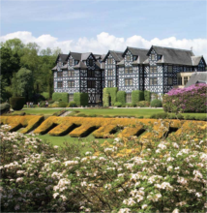
WALES MATHEMATICS COLLOQUIUM 2013
20th -22nd May at Gregynog Hall, Tregynon, nr Newtown, Powys
The themes this year are (i) Spectral theory (ii) Uncertainty in mathematical modelling
The Guest Speakers will include:
Professor Brian Davies, Kings College London
Professor Sofia Olhede, University College London

If you would like to give a research talk (it does not have to be on the general theme) please contact a local organiser (Prof Russell Davies, Cardiff, Prof Simon Cox, Aberystwyth, Prof Derek Smith, Glamorgan, Dr Edwin Beggs, Swansea) or email daviesr@cardiff.ac.uk
To attend please complete the form at www.wimcs.ac.uk/gregynog.html and return to administrator@wimcs.ac.uk
